STUDENT RECORDS APPLICATION

To develop and implement a Student Records REST API using Spring Boot and MongoDB.
The application provides functionality for:
- User registration
- User login
- JWT-based authentication
- Creating student records
- Retrieving student records
- Updating student records
- Deleting student records
- MongoDB-based data storage
The application is developed and executed using Visual Studio Code, with MongoDB used as the database.

Project Structure
The project contains the following main packages:
com.example.studentrecords
│
├── controller
├── dto
├── entity
├── exception
├── repository
├── security
├── service
│
└── StudentRecordsApplication.java
The project also contains:
pom.xml
src/main/resources/application.properties
mvnw
mvnw.cmd
.mvn
The implementation guide specifies this package organization for the Student Records application.
Screenshot 1 – Project Structure
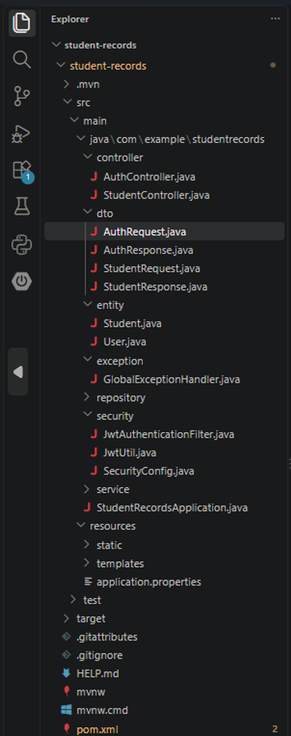

5. MongoDB Configuration
The application is configured to connect to MongoDB using:
mongodb://localhost:27017/student_records
The application uses the database:
student_records
Student records are stored in the:
students
collection.
User records are stored in the:
users
collection.
Screenshot 2 – MongoDB Compass
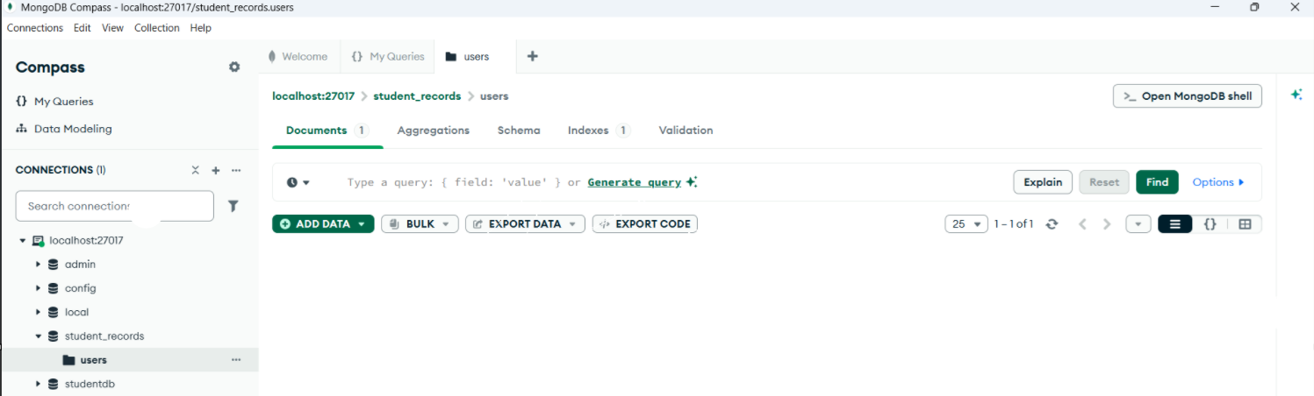
6. Application Configuration
The application.properties file contains the MongoDB connection and server configuration.
spring.application.name=student-records

spring.data.mongodb.uri=mongodb://localhost:27017/student_records

server.port=8080
The application runs on:
http://localhost:8080
The project guide specifies port 8080 and the student_records MongoDB database.
Screenshot 3 – application.properties
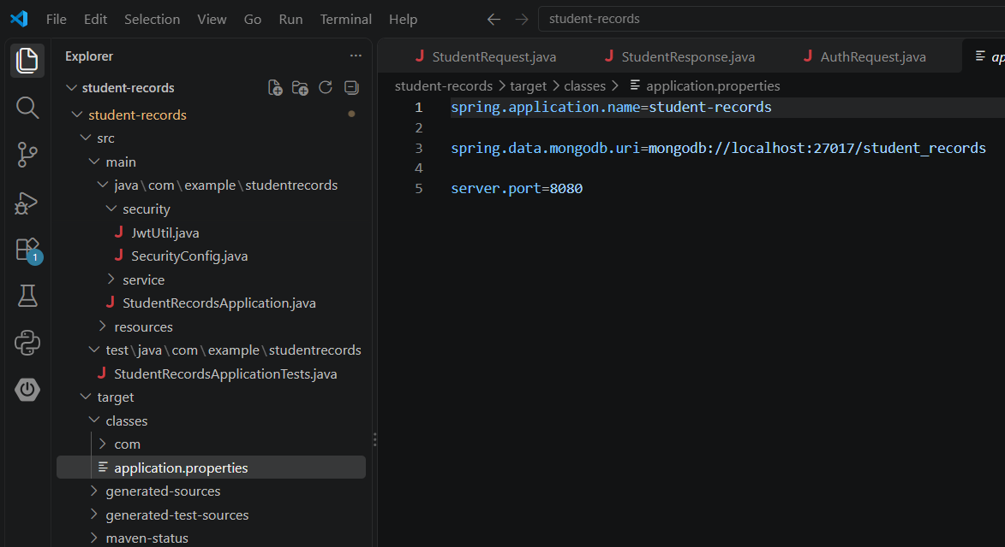

Project Compilation
The project was compiled using Maven.
Command used:
mvn compile
The project compiled successfully with:
BUILD SUCCESS
The compiler successfully compiled the project using Java release 17. Your final compilation showed 17 source files and BUILD SUCCESS.
Screenshot 4 – Successful Maven Compilation
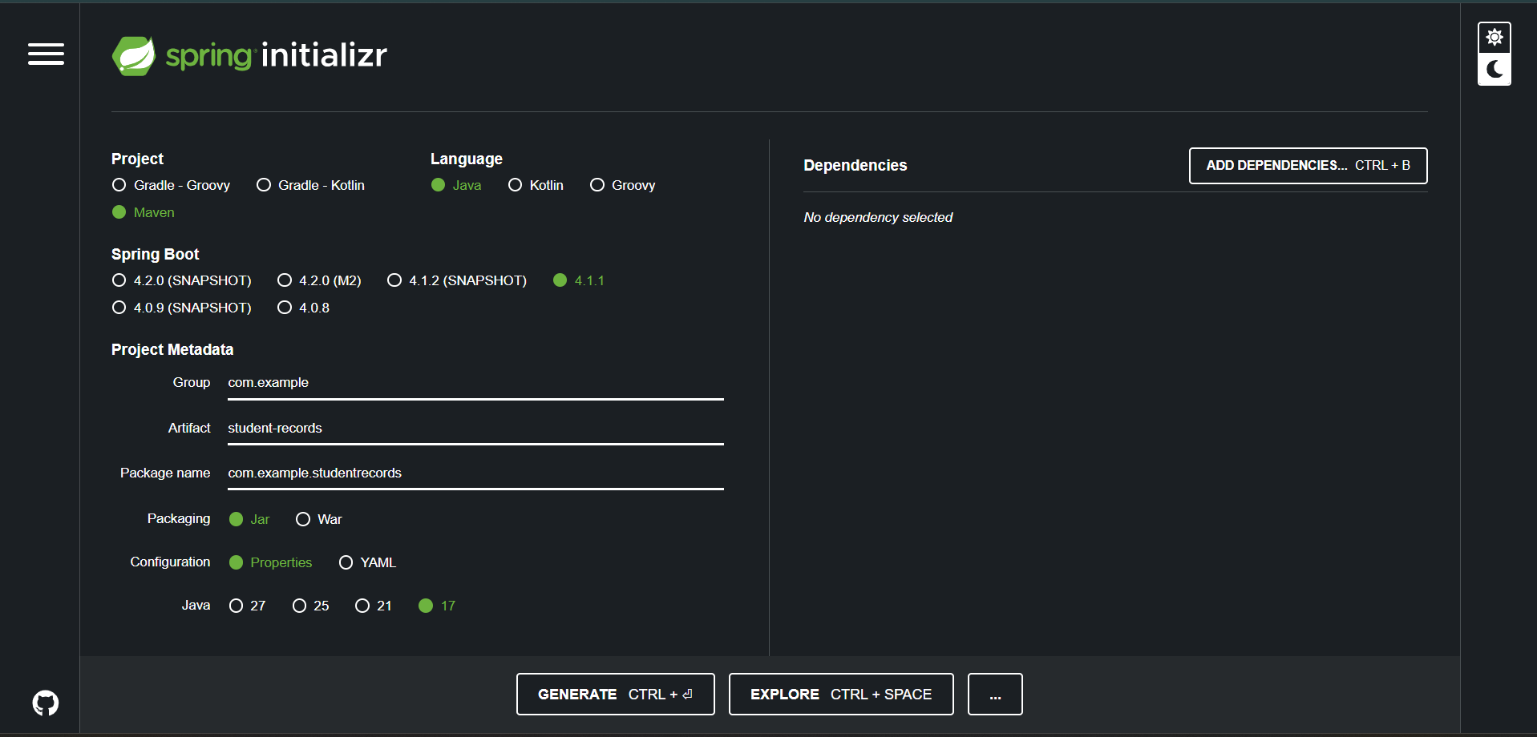

Running the Spring Boot Application
The application was started using:
mvn spring-boot:run
The application successfully started on port 8080.
The console displayed:
Tomcat started on port 8080 (http)
and:
Started StudentRecordsApplication
The application also successfully connected to MongoDB at localhost:27017.
Screenshot 5 – Spring Boot Application Running
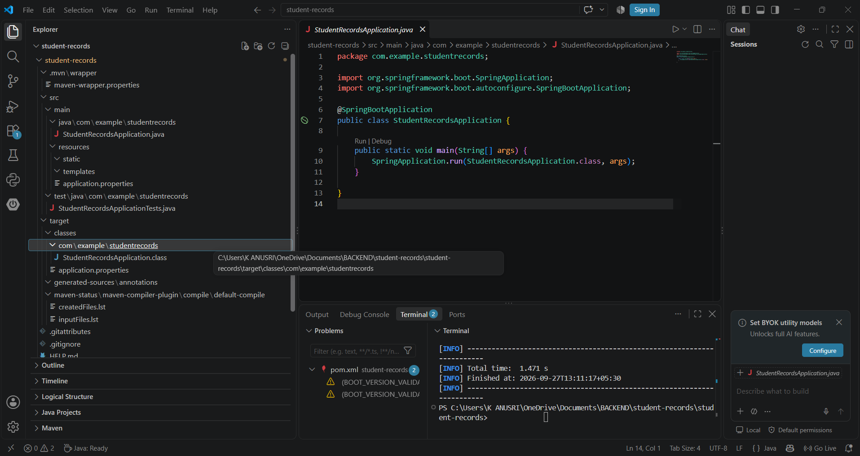

User Registration
The registration API was tested using Postman.
Request
Method:
POST
URL:
http://localhost:8080/auth/register
Request Body
{
"username": "anu",
"password": "123456"
}
The user was successfully registered and stored in MongoDB.
Screenshot 6 – User Registration
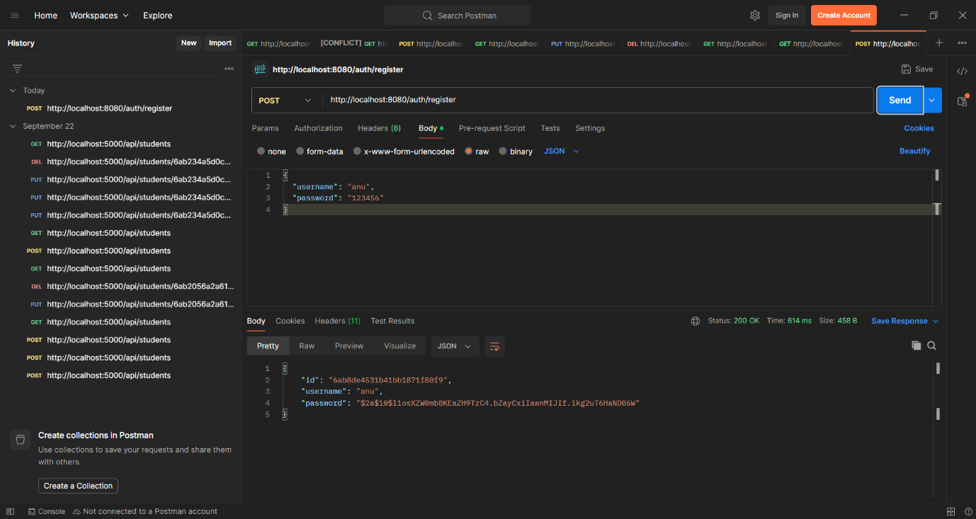

User Login and JWT Authentication
The login API was tested using Postman.
Request
Method:
POST
URL:
http://localhost:8080/auth/login
Request Body
{
"username": "anu",
"password": "123456"
}
The API returned a JWT token after successful authentication.
Response
{
"token": "JWT_TOKEN"
}
The JWT token is then used to access protected student endpoints.
The project guide specifies registration, login, JWT generation and use of the JWT as a Bearer token for protected requests.
Screenshot 7 – Login and JWT Token
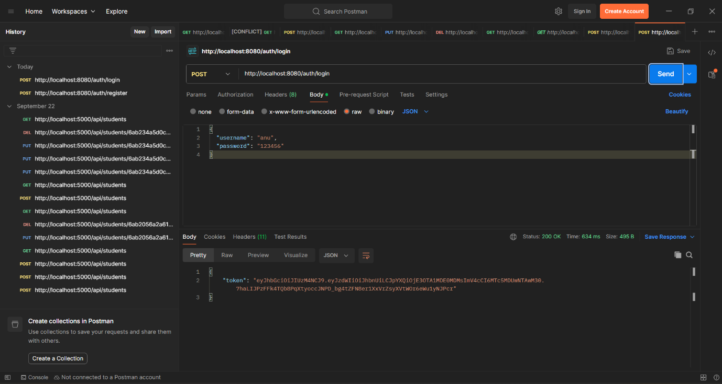

Create Student Record
Screenshot 8 – Create Student
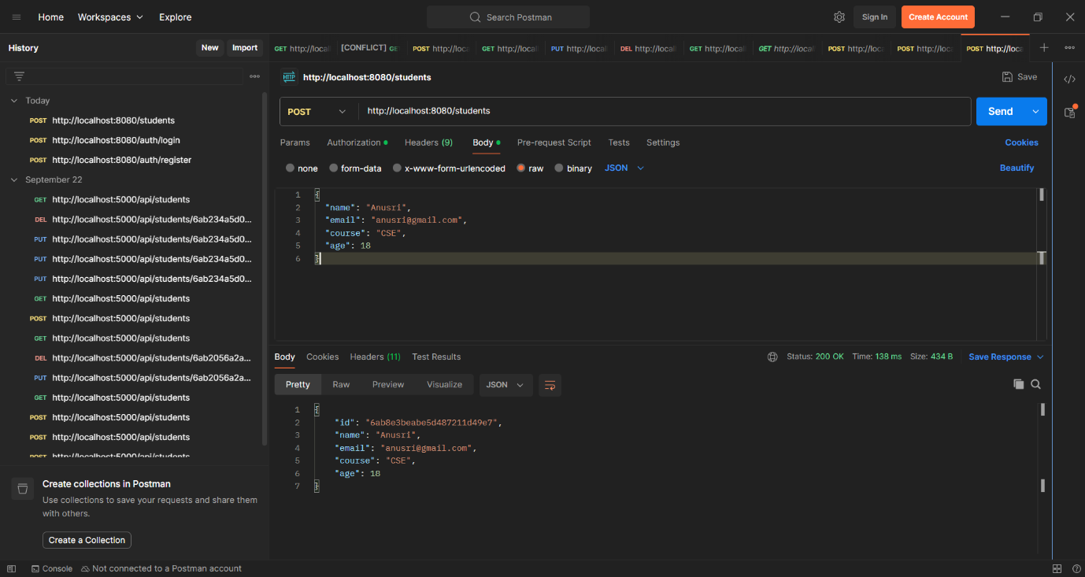

Retrieve Student Records
Screenshot 9 – Get All Students
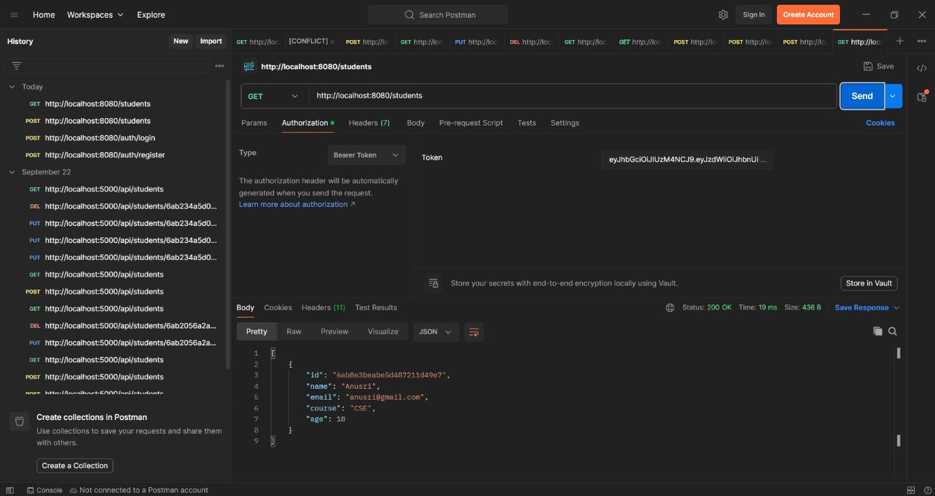

MongoDB Student Record
Screenshot 10 – Student Record in MongoDB Compass
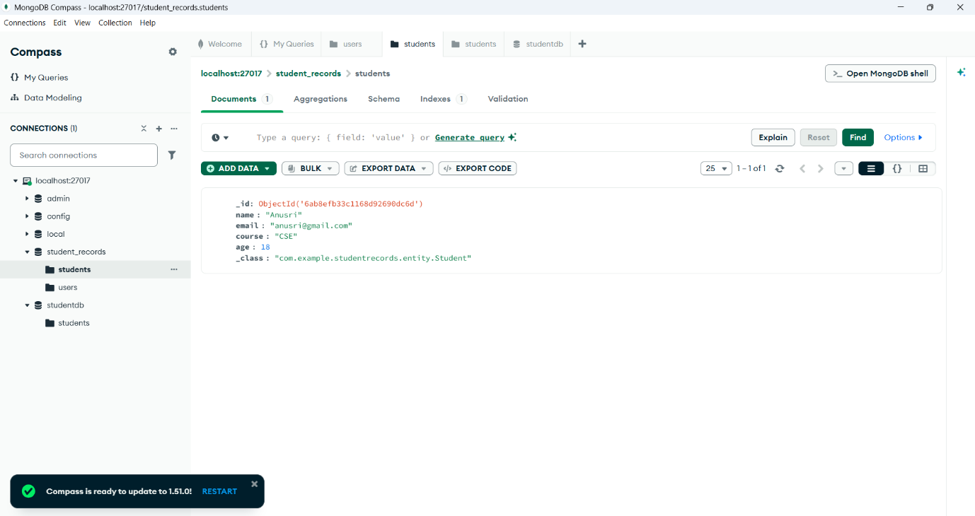

Screenshot 11 – JWT Protected Request
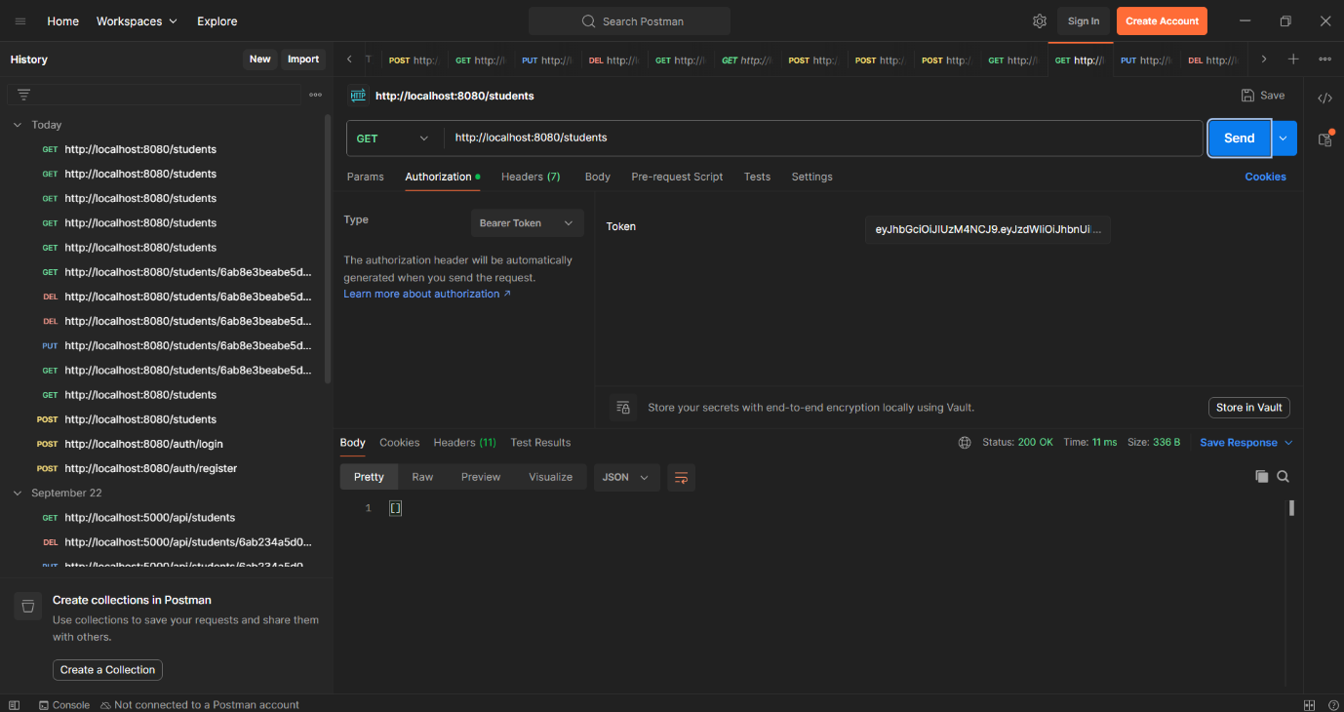

Result
The Student Records Application was successfully implemented using Spring Boot and MongoDB.
The application successfully demonstrated:
- User registration
- User login
- JWT token generation
- JWT-protected student API
- Student record creation
- Student record retrieval
- MongoDB data storage
The application successfully connected to MongoDB and ran on port 8080. The implementation guide describes the application as a REST API supporting student-record CRUD operations with authentication and MongoDB persistence.

